The Electoral College Map Challenge
No Calculators

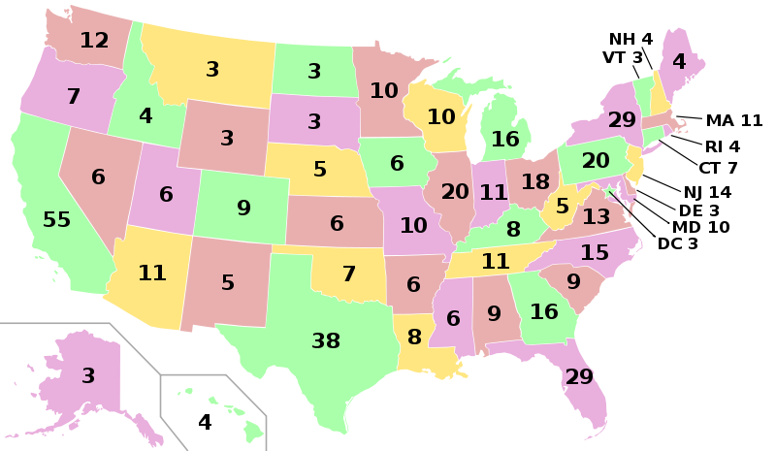

- A presidential candidate must win More than 50% of the votes in a state to win all the points in the state
- A presidential candidate needs 270 points to win the Presidential Election

Your Challenge – Get elected by visiting the least amount of states

- Turn in both parts for a grade before the end of class
No Calculators

Part 1

- You can start in any state
- Every state you visit = you win all the points of that state
- Imagine “visiting” as making moves on a game board
- When you move to another state, you can only move to a connected state. For example, if you are in Virginia, the next move can only be a connected state (North Carolina, Tennessee, West Virginia, Kentucky, or Maryland)
- Reach 270 points in the least amount of moves possible

- On a piece of you own paper – write down the states (with points) you visit in correct order
- Add it up to make sure you get over 270
- Person with the least amount of moves wins a prize

Part 2

- Imagine you are running for president and you need to earn 270 electoral votes. However, your time is limited. You can only campaign in 1/3rd of the states (17 states).

- In which 17 states would a smart candidate spend their campaign time? (write on piece of paper)
- In which 17 states would a stupid candidate spend their campaign time? (write on piece of paper)

Part 3

- Simplifying Ratios. Each State is worth a certain amount of points. If you were to compare the two, you would have a ratio. For example, California has 55 pts. & Arizona has 11 pts. That’s a ration of 55:11. If I wanted to simplify this ratio, I would find the Greatest Common Divisor (the biggest positive number that divides both without a remainder). In this case it is 11. 55/11= 5 & 11/11 = 1. The ratio is 5:1 (California has 5 times the population of Arizona)

- Simplify the following state electoral vote ratios: a. Ohio & Vermont b. Idaho & Illinois c. California & North Carolina
d. Louisiana & Texas e. New York & Florida f. Washington & Pennsylvania
No Calculators

