u3 day 5 – Judicial Branch
Dual Court System = 2 court systems

- Federal

- State
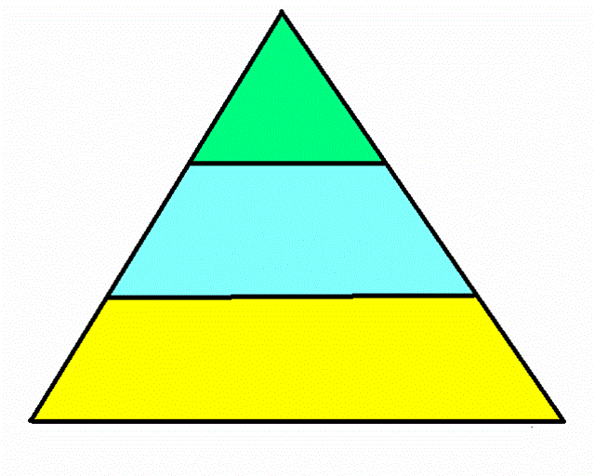

Supreme Court

U.S. Circuit Court
of Appeals

U.S. District Court

Federal Court System

Federal Courts
- Jurisdiction = area a court has authority over - Original: hold the 1st Trial
- Appellate: can re-do cases from lower court
- Limited: can only hear special cases

Supreme Court
Who: 9 Justices
What:
- Limited-Original Jurisdiction
- Appellate Jurisdiction

U.S. Circuit Court of Appeals
Who: Justices no Jury
What:
- Appellate jurisdiction

U.S. District Court
Who: Judge & Jury
What:
- Original Jurisdiction

u3 day 6

Criminal Law
- Breaking The Law
- Felony = Major Crime
- murder, theft over $200
- Misdemeanor = Small Crime
- vandalism, theft under $200

Criminal Law Procedure
- Arrest with PROBABLE CAUSE (evidence)
- Jailed or released on bail
- Arraignment
    - Plea entered
    - Probable Cause is reviewed
    - Attorney may be appointed
    - Court date is set
- Trial is conducted
- Verdict
- Guilty verdict may be appealed to a higher court

Civil Law Procedure
- Plaintiff files a complaint against the defendant
- Judge or Judge & Jury give a verdict
- Verdict may be appealed to a higher court

Juvenile Court Procedure
- Judge has more freedom to make decisions than adult cases
- Juvenile may be tried as an adult

